25.10.1 Editors - Properties Editor - Physics - Force Fields Panel
Detailed table of content 1
Force Fields panel 8
Type 8
Type Force 8
Settings subpanel 8
Falloff Subpanel 9
Type Wind 10
Settings Subpanel 10
Falloff Subpanel 11
Type Vortex 12
Settings Subpanel 12
Falloff Subpanel 13
Type Magnetic 14
Settings Subpanel 14
Falloff Subpanel 14
Type Harmonic 15
Settings Subpanel 15
Falloff Subpanel 16
Type Charge 17
Settings Subpanel 17
Falloff Subpanel 18
Type Lennard Jones 19
Settings Subpanel 19
Falloff Subpanel 20
Type Texture 21
Settings Subpanel 21
Falloff Subpanel 22
Type Curve Guide 23
Settings subpanel 24
Type Boid 25
Settings Subpanel 25
Falloff Subpanel 26
Type Turbulence 27
Settings Subpanel 27
Falloff Subpanel 28
Type Drag 29
Settings Subpanel 29
Falloff Subpanel 30
Type Fluid Flow 31
Settings Subpanel 31
Falloff Subpanel 31

Detailed table of content
25.10.1 Editors - Properties Editor - Physics - Force Fields Panel
Detailed table of content 1
Force Fields panel 8
Type 8
Type Force 8
Settings subpanel 8
Shape 8
Strength 8
Flow / Inflow 8
Affect 9
Location 9
Rotation 9
Noise Amount 9
Seed 9
Gravitation 9
Absorption 9
Wind Factor 9
Falloff Subpanel 9
Shape 9
Sphere 9
Tube 9
Cone 9
Z Direction 10
Power (Power) 10
Min Distance 10
Max Distance 10
Type Wind 10
Settings Subpanel 10
Shape 10
Strength 10
Flow / Inflow 10
Affect 10
Location 10
Rotation 11
Noise Amount 11
Seed 11
Absorption 11
Wind Factor 11
Falloff Subpanel 11
Shape 11
Sphere 11
Tube 11
Cone 11
Z Direction 11
Power (Power) 11
Min Distance 12
Max Distance 12
Type Vortex 12
Settings Subpanel 12
Shape 12
Strength 12
Flow / Inflow 12
Affect 12
Location 12
Rotation 12
Noise Amount 12
Seed 12
Absorption 13
Wind Factor 13
Falloff Subpanel 13
Shape 13
Sphere 13
Tube 13
Cone 13
Z Direction 13
Power (Power) 13
Min Distance 13
Max Distance 13
Type Magnetic 14
Settings Subpanel 14
Shape 14
Strength 14
Flow 14
Affect 14
Location 14
Rotation 14
Noise Amount 14
Seed 14
Absorption 14
Wind Factor 14
Falloff Subpanel 14
Shape 15
Sphere 15
Tube 15
Cone 15
Z Direction 15
Power (Power) 15
Min Distance 15
Max Distance 15
Type Harmonic 15
Settings Subpanel 15
Shape 16
Strength 16
Damping 16
Rest Length 16
Affect 16
Location 16
Rotation 16
Noise Amount 16
Seed 16
Multiple Springs 16
Absorption 16
Wind Factor 16
Falloff Subpanel 16
Shape 17
Sphere 17
Tube 17
Cone 17
Z Direction 17
Power (Power) 17
Min Distance 17
Max Distance 17
Type Charge 17
Settings Subpanel 17
Shape 18
Strength 18
Flow 18
Affect 18
Location 18
Rotation 18
Noise Amount 18
Seed 18
Absorption 18
Wind Factor 18
Falloff Subpanel 18
Shape 18
Sphere 18
Tube 18
Cone 19
Z Direction 19
Power (Power) 19
Min Distance 19
Max Distance 19
Type Lennard Jones 19
Settings Subpanel 19
Shape 19
Strength 19
Flow 19
Affect 20
Location 20
Rotation 20
Noise Amount 20
Seed 20
Absorption 20
Wind Factor 20
Falloff Subpanel 20
Shape 20
Sphere 20
Tube 20
Cone 20
Z Direction 20
Power (Power) 20
Min Distance 21
Max Distance 21
Type Texture 21
Settings Subpanel 21
Texture mode 21
RGB 21
Gradient 21
Curl 21
Strength 21
Nabla 22
Use Coordinates 22
2D 22
Texture Sub Subpanel 22
Texture Property 22
Texture Browser 22
Name 22
Fake User 22
New Texture 22
Remove 22
Show Texture in Texture Tab 22
Falloff Subpanel 22
Shape 22
Sphere 22
Tube 22
Cone 23
Z Direction 23
Power (Power) 23
Min Distance 23
Max Distance 23
Type Curve Guide 23
Settings subpanel 24
Minimum Distance 24
Free 24
Falloff Power 24
Additive 24
Weights 24
Clumping Amount 24
Shape 24
Use Max 24
Kink sub subpanel 24
Type 24
Curl 24
Radial 24
Wave 25
Braid 25
Roll 25
Axis 25
Frequency 25
Shape 25
Amplitude 25
Type Boid 25
Settings Subpanel 25
Shape 25
Strength 25
Flow 25
Affect 26
Location 26
Rotation 26
Noise Amount 26
Seed 26
Absorption 26
Wind Factor 26
Falloff Subpanel 26
Shape 26
Sphere 26
Tube 26
Cone 26
Z Direction 26
Power (Power) 27
Min Distance 27
Max Distance 27
Type Turbulence 27
Settings Subpanel 27
Shape 27
Strength 27
Size 27
Flow 27
Affect 28
Location 28
Rotation 28
Noise Amount 28
Seed 28
Global 28
Absorption 28
Wind Factor 28
Falloff Subpanel 28
Shape 28
Sphere 28
Tube 28
Cone 28
Z Direction 28
Power (Power) 29
Min Distance 29
Max Distance 29
Type Drag 29
Settings Subpanel 29
Shape 29
Linear 29
Quadratic 29
Affect 29
Location 29
Rotation 29
Noise Amount 30
Seed 30
Absorption 30
Wind Factor 30
Falloff Subpanel 30
Shape 30
Sphere 30
Tube 30
Cone 30
Z Direction 30
Power (Power) 30
Min Distance 30
Max Distance 31
Type Fluid Flow 31
Settings Subpanel 31
Shape 31
Strength 31
Flow 31
Domain Object 31
Apply Density 31
Falloff Subpanel 31
Shape 31
Sphere 31
Tube 31
Cone 32
Z Direction 32
Power (Power) 32
Min Distance 32
Max Distance 32

Force Fields panel

Force Fields offer a way to add extra movement to dynamic systems like Particles, Soft Bodies, Rigid Bodies and Cloth objects.
Note that when you work with particles, softbody or cloth system and change one of the force fields parameters, then you need to recalculate the particles, softbody or cloth systems.

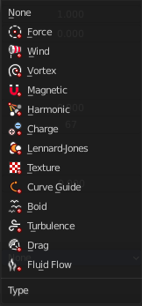
Type
There are several force field types available.

Type Force
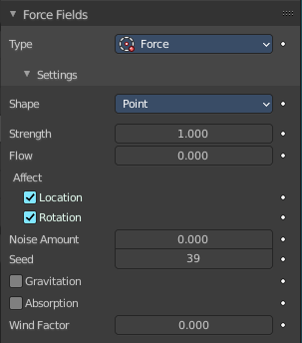
A Force type force field gives a constant force towards (positive strength) or away from (negative strength) the object’s center.
For Boids a field with positive strength can be used as a Goal. A field with negative strength can be used as Predator. Whether Boids seek or fly goals/predators depends on the Physics settings of the Boids.

Settings subpanel

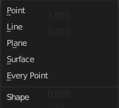
Shape
The direction that is used to calculate the effector force.

Strength
The strength of the force.

Flow / Inflow
Convert effector force into air force velocity / Inwards component of the force.

Affect

Location
Affect the location of the particles.

Rotation
Affect the rotation of the particles.

Noise Amount
Amount of noise for the force effect.

Seed
The random seed for the noise amount.

Gravitation
Multiply force by 1 divided through the distance in square.

Absorption
Force gets absorbed by collision objects.

Wind Factor
How much the force is reduced when acting parallel to a surface. Like a cloth.

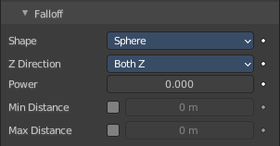
Falloff Subpanel

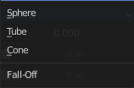
Shape

Sphere
Falloff is uniform in all directions, as in a sphere.

Tube
Fall off results in a tube shaped force field. The Field’s Radial falloff can be adjusted, as well as the Minimum and Maximum distances of the field.

Cone
Fall off results in a cone shaped force field. Additional options are the same as those of Tube options.

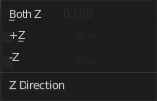
Z Direction
Fall-off can be set to apply only in the direction of the positive Z Axis, negative Z Axis, or both.

Power (Power)
How the power of the force field changes with the distance from the force field. If r is the distance from the center of the object, the force changes with 1/rPower. A Fall-off of 2 changes the force field with 1/r2, which is the falloff of gravitational pull.

Min Distance
The distance from the object center, up to where the force field is effective with full strength. If you have a Fall-off of 0 this parameter does nothing, because the field is effective with full strength up to Max Dist (or the infinity). Shown by an additional circle around the object.

Max Distance
Makes the force field only take effect within a specified maximum radius (shown by an additional circle around the object).

Type Wind
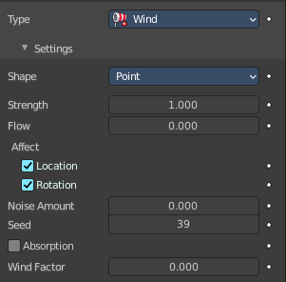
Constant force along the Z axis.

Settings Subpanel

Shape
The direction that is used to calculate the effector force.

Strength
The strength of the force.

Flow / Inflow
Convert effector force into air force velocity / Inwards component of the force.

Affect

Location
Affect the location of the particles.

Rotation
Affect the rotation of the particles.

Noise Amount
Amount of noise for the force effect.

Seed
The random seed for the noise amount.

Absorption
Force gets absorbed by collision objects.

Wind Factor
How much the force is reduced when acting parallel to a surface. Like a cloth.

Falloff Subpanel

Shape

Sphere
Falloff is uniform in all directions, as in a sphere.

Tube
Fall off results in a tube shaped force field. The Field’s Radial falloff can be adjusted, as well as the Minimum and Maximum distances of the field.

Cone
Fall off results in a cone shaped force field. Additional options are the same as those of Tube options.

Z Direction
Fall-off can be set to apply only in the direction of the positive Z Axis, negative Z Axis, or both.

Power (Power)
How the power of the force field changes with the distance from the force field. If r is the distance from the center of the object, the force changes with 1/rPower. A Fall-off of 2 changes the force field with 1/r2, which is the falloff of gravitational pull.

Min Distance
The distance from the object center, up to where the force field is effective with full strength. If you have a Fall-off of 0 this parameter does nothing, because the field is effective with full strength up to Max Dist (or the infinity). Shown by an additional circle around the object.

Max Distance
Makes the force field only take effect within a specified maximum radius (shown by an additional circle around the object).

Type Vortex
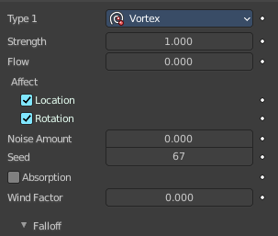
Spiraling force that twists the force object's local Z axis. Use case could be a tornado for example.

Settings Subpanel

Shape
The direction that is used to calculate the effector force.

Strength
The strength of the force.

Flow / Inflow
Convert effector force into air force velocity / Inwards component of the force.

Affect

Location
Affect the location of the particles.

Rotation
Affect the rotation of the particles.

Noise Amount
Amount of noise for the force effect.

Seed
The random seed for the noise amount.

Absorption
Force gets absorbed by collision objects.

Wind Factor
How much the force is reduced when acting parallel to a surface. Like a cloth.

Falloff Subpanel

Shape

Sphere
Falloff is uniform in all directions, as in a sphere.

Tube
Fall off results in a tube shaped force field. The Field’s Radial falloff can be adjusted, as well as the Minimum and Maximum distances of the field.

Cone
Fall off results in a cone shaped force field. Additional options are the same as those of Tube options.

Z Direction
Fall-off can be set to apply only in the direction of the positive Z Axis, negative Z Axis, or both.

Power (Power)
How the power of the force field changes with the distance from the force field. If r is the distance from the center of the object, the force changes with 1/rPower. A Fall-off of 2 changes the force field with 1/r2, which is the falloff of gravitational pull.

Min Distance
The distance from the object center, up to where the force field is effective with full strength. If you have a Fall-off of 0 this parameter does nothing, because the field is effective with full strength up to Max Dist (or the infinity). Shown by an additional circle around the object.

Max Distance
Makes the force field only take effect within a specified maximum radius (shown by an additional circle around the object).

Type Magnetic
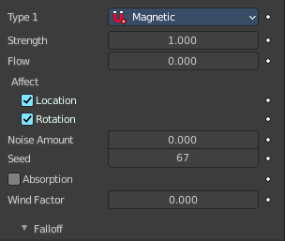
A magnetic force field simulates the force of magnetism on magnetized objects.

Settings Subpanel

Shape
The direction that is used to calculate the effector force.

Strength
The strength of the force.

Flow
Convert effector force into air force velocity.

Affect

Location
Affect the location of the particles.

Rotation
Affect the rotation of the particles.

Noise Amount
Amount of noise for the force effect.

Seed
The random seed for the noise amount.

Absorption
Force gets absorbed by collision objects.

Wind Factor
How much the force is reduced when acting parallel to a surface. Like a cloth.

Falloff Subpanel

Shape

Sphere
Falloff is uniform in all directions, as in a sphere.

Tube
Fall off results in a tube shaped force field. The Field’s Radial falloff can be adjusted, as well as the Minimum and Maximum distances of the field.

Cone
Fall off results in a cone shaped force field. Additional options are the same as those of Tube options.

Z Direction
Fall-off can be set to apply only in the direction of the positive Z Axis, negative Z Axis, or both.

Power (Power)
How the power of the force field changes with the distance from the force field. If r is the distance from the center of the object, the force changes with 1/rPower. A Fall-off of 2 changes the force field with 1/r2, which is the falloff of gravitational pull.

Min Distance
The distance from the object center, up to where the force field is effective with full strength. If you have a Fall-off of 0 this parameter does nothing, because the field is effective with full strength up to Max Dist (or the infinity). Shown by an additional circle around the object.

Max Distance
Makes the force field only take effect within a specified maximum radius (shown by an additional circle around the object).

Type Harmonic
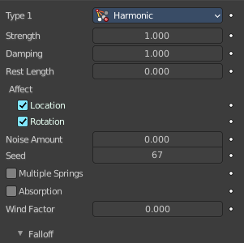
The source of this force field is the zero point of a harmonic oscillator. If you set the Damping parameter to 1, the movement is stopped in the moment the object is reached.

Settings Subpanel

Shape
The direction that is used to calculate the effector force.

Strength
The strength of the force.

Damping
Damping of the harmonic force.

Rest Length
The rest length of the harmonic force.

Affect

Location
Affect the location of the particles.

Rotation
Affect the rotation of the particles.

Noise Amount
Amount of noise for the force effect.

Seed
The random seed for the noise amount.

Multiple Springs
Every point is effected by multiple springs.

Absorption
Force gets absorbed by collision objects.

Wind Factor
How much the force is reduced when acting parallel to a surface. Like a cloth.

Falloff Subpanel

Shape

Sphere
Falloff is uniform in all directions, as in a sphere.

Tube
Fall off results in a tube shaped force field. The Field’s Radial falloff can be adjusted, as well as the Minimum and Maximum distances of the field.

Cone
Fall off results in a cone shaped force field. Additional options are the same as those of Tube options.

Z Direction
Fall-off can be set to apply only in the direction of the positive Z Axis, negative Z Axis, or both.

Power (Power)
How the power of the force field changes with the distance from the force field. If r is the distance from the center of the object, the force changes with 1/rPower. A Fall-off of 2 changes the force field with 1/r2, which is the falloff of gravitational pull.

Min Distance
The distance from the object center, up to where the force field is effective with full strength. If you have a Fall-off of 0 this parameter does nothing, because the field is effective with full strength up to Max Dist (or the infinity). Shown by an additional circle around the object.

Max Distance
Makes the force field only take effect within a specified maximum radius (shown by an additional circle around the object).

Type Charge
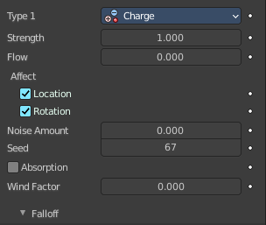
Special force field based on the charge of particles. Chartge force fields just affects other charge force fields.

Settings Subpanel

Shape
The direction that is used to calculate the effector force.

Strength
The strength of the force.

Flow
Convert effector force into air force velocity.

Affect

Location
Affect the location of the particles.

Rotation
Affect the rotation of the particles.

Noise Amount
Amount of noise for the force effect.

Seed
The random seed for the noise amount.

Absorption
Force gets absorbed by collision objects.

Wind Factor
How much the force is reduced when acting parallel to a surface. Like a cloth.

Falloff Subpanel

Shape

Sphere
Falloff is uniform in all directions, as in a sphere.

Tube
Fall off results in a tube shaped force field. The Field’s Radial falloff can be adjusted, as well as the Minimum and Maximum distances of the field.

Cone
Fall off results in a cone shaped force field. Additional options are the same as those of Tube options.

Z Direction
Fall-off can be set to apply only in the direction of the positive Z Axis, negative Z Axis, or both.

Power (Power)
How the power of the force field changes with the distance from the force field. If r is the distance from the center of the object, the force changes with 1/rPower. A Fall-off of 2 changes the force field with 1/r2, which is the falloff of gravitational pull.

Min Distance
The distance from the object center, up to where the force field is effective with full strength. If you have a Fall-off of 0 this parameter does nothing, because the field is effective with full strength up to Max Dist (or the infinity). Shown by an additional circle around the object.

Max Distance
Makes the force field only take effect within a specified maximum radius (shown by an additional circle around the object).

Type Lennard Jones

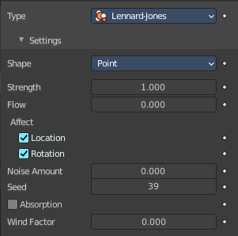
Force field based on the lennard jones potential. The Lennard-Jones potential describes the interactions of two neutral particles using a relatively simple mathematical model. At a distance smaller than the combined sizes the field is very repulsive and after that distance it’s attractive.
Particles can have for example both a charge and a Lennard-Jones potential.

Settings Subpanel

Shape
The direction that is used to calculate the effector force.

Strength
The strength of the force.

Flow
Convert effector force into air force velocity.

Affect

Location
Affect the location of the particles.

Rotation
Affect the rotation of the particles.

Noise Amount
Amount of noise for the force effect.

Seed
The random seed for the noise amount.

Absorption
Force gets absorbed by collision objects.

Wind Factor
How much the force is reduced when acting parallel to a surface. Like a cloth.

Falloff Subpanel

Shape

Sphere
Falloff is uniform in all directions, as in a sphere.

Tube
Fall off results in a tube shaped force field. The Field’s Radial falloff can be adjusted, as well as the Minimum and Maximum distances of the field.

Cone
Fall off results in a cone shaped force field. Additional options are the same as those of Tube options.

Z Direction
Fall-off can be set to apply only in the direction of the positive Z Axis, negative Z Axis, or both.

Power (Power)
How the power of the force field changes with the distance from the force field. If r is the distance from the center of the object, the force changes with 1/rPower. A Fall-off of 2 changes the force field with 1/r2, which is the falloff of gravitational pull.

Min Distance
The distance from the object center, up to where the force field is effective with full strength. If you have a Fall-off of 0 this parameter does nothing, because the field is effective with full strength up to Max Dist (or the infinity). Shown by an additional circle around the object.

Max Distance
Makes the force field only take effect within a specified maximum radius (shown by an additional circle around the object).

Type Texture

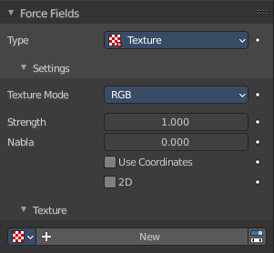
Adds a force field based on a texture.The force in the 3 directions is color coded.
Red is coding for the x-axis, green for the y-axis and blue for the z-axis. A value of 0.5 means no force, a value larger than 0.5 acceleration in negative axis direction (like -Z), a value smaller than 0.5 acceleration in positive axis direction (like +Z).

Settings Subpanel

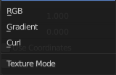
Texture mode
This sets the way a force vector is derived from the texture.

RGB
Uses the color components directly as the force vector components in the color encoded directions. You need an RGB texture for this, e.g. an image or a colorband. So a Blend texture without a colorband would not suffice.

Gradient
Calculates the force vector as the 3d-gradient of the intensity (grayscale) of the texture. The gradient vector always points to the direction of increasing brightness.

Curl
Calculates the force vector from the curl of the 3d-rgb texture (rotation of rgb vectors). This also works only with a color texture. It can be used for example to create a nice looking turbulence force with a color clouds texture with perlin noise.

Strength
The strength of the force.

Nabla
It is the offset used to calculate the partial derivatives needed for Gradient and Curl texture modes.

Use Coordinates
Uses the emitter object coordinates as the texture space the particles use.

2D
Apply force only in 2D.

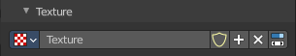
Texture Sub Subpanel

Texture Property

Texture Browser
A list of the available textures in the scene.

Name
The name of the currently active texture. You can rename the texture here by clicking at the edit box.

Fake User
Keep this texture in the scene even if it has no user.

New Texture
Add a new texture.

Remove
Remove the texture.

Show Texture in Texture Tab
Jumps to the texture tab where you can edit your texture.

Falloff Subpanel

Shape

Sphere
Falloff is uniform in all directions, as in a sphere.

Tube
Fall off results in a tube shaped force field. The Field’s Radial falloff can be adjusted, as well as the Minimum and Maximum distances of the field.

Cone
Fall off results in a cone shaped force field. Additional options are the same as those of Tube options.

Z Direction
Fall-off can be set to apply only in the direction of the positive Z Axis, negative Z Axis, or both.

Power (Power)
How the power of the force field changes with the distance from the force field. If r is the distance from the center of the object, the force changes with 1/rPower. A Fall-off of 2 changes the force field with 1/r2, which is the falloff of gravitational pull.

Min Distance
The distance from the object center, up to where the force field is effective with full strength. If you have a Fall-off of 0 this parameter does nothing, because the field is effective with full strength up to Max Dist (or the infinity). Shown by an additional circle around the object.

Max Distance
Makes the force field only take effect within a specified maximum radius (shown by an additional circle around the object).

Type Curve Guide

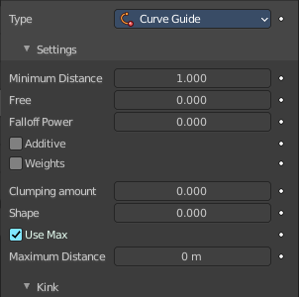
Creates a force along a curve object.
A typical scenario would be to move a red blood cell inside a vein, or to animate the particle flow in a motor. You can use Curve Guide s also to shape certain hair strands.
Note! You can also use the Particle Mode to define a path.
The option Curve Follow does not work for particles. Instead you have to set Angular Velocity in the Physics panel of the Particle sub-context to Spin and leave the rotation constant. For example don’t turn on Dynamic.
Curve Guide s affect all particles on the same layer, independently from their distance to the curve. If you have several guides in a layer, their fields add up to each other (the way you may have learned it in your physics course). But you can limit their influence radius by changing there Minimum Distance (see below).
Note! The Curve Guide does not effect Softbodys.

Settings subpanel

Minimum Distance
The distance from the curve, up to where the force field is effective with full strength. If you have a Fall-off of 0 this parameter does nothing, because the field is effective with full strength up to MaxDist (or the infinity). MinDist is shown with a circle at the endpoints of the curve in the 3D window.

Free
Fraction of particle life time, that is not used for the curve.

Falloff Power
How quickly strength falls off with distance from the force field. A Fall-off of 1 means a linear progression.

Additive
If you use Additive, the speed of the particles is also evaluated depending on the Fall-off.

Weights
Use Curve weights to influence the particle influence along the curve.

Clumping Amount
The particles come together at the end of the curve (1) or they drift apart (-1).

Shape
Defines the form in which the particles come together. +0.99: the particles meet at the end of the curve. 0: linear progression along the curve. -0.99: the particles meet at the beginning of the curve.

Use Max
The maximum influence radius. Shown by an additional circle around the curve object.
The other settings govern the form of the force field along the curve.

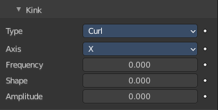
Kink sub subpanel
Kink changes the shape that the particles can take. It adds an offset.

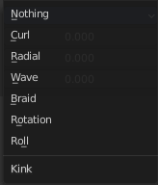
Type

Curl
The radius of the influence depends on the distance of the curve to the emitter.

Radial
A three dimensional, standing wave.

Wave
A two dimensional, standing wave.

Braid
Braid.

Roll
A one dimensional, standing wave.

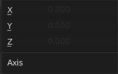
Axis
Which axis to use for the offset.

Frequency
The frequency of the offset.

Shape
Adjust the offset to the beginning/end.

Amplitude
The Amplitude of the offset.

Type Boid
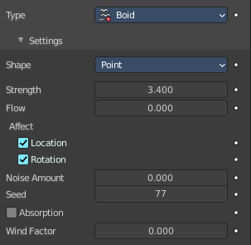
Creates a force that acts as a boid's predator or target. Boids simulates the flocking behaviour of birds.

Settings Subpanel

Shape
The direction that is used to calculate the effector force.

Strength
The strength of the force.

Flow
Convert effector force into air force velocity.

Affect

Location
Affect the location of the particles.

Rotation
Affect the rotation of the particles.

Noise Amount
Amount of noise for the force effect.

Seed
The random seed for the noise amount.

Absorption
Force gets absorbed by collision objects.

Wind Factor
How much the force is reduced when acting parallel to a surface. Like a cloth.

Falloff Subpanel

Shape

Sphere
Falloff is uniform in all directions, as in a sphere.

Tube
Fall off results in a tube shaped force field. The Field’s Radial falloff can be adjusted, as well as the Minimum and Maximum distances of the field.

Cone
Fall off results in a cone shaped force field. Additional options are the same as those of Tube options.

Z Direction
Fall-off can be set to apply only in the direction of the positive Z Axis, negative Z Axis, or both.

Power (Power)
How the power of the force field changes with the distance from the force field. If r is the distance from the center of the object, the force changes with 1/rPower. A Fall-off of 2 changes the force field with 1/r2, which is the falloff of gravitational pull.

Min Distance
The distance from the object center, up to where the force field is effective with full strength. If you have a Fall-off of 0 this parameter does nothing, because the field is effective with full strength up to Max Dist (or the infinity). Shown by an additional circle around the object.

Max Distance
Makes the force field only take effect within a specified maximum radius (shown by an additional circle around the object).

Type Turbulence
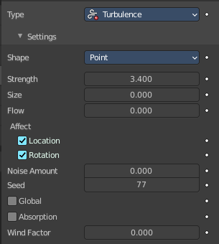
Create turbulence with a noise field. This creates a random and chaotic 3D noise effect.

Settings Subpanel

Shape
The direction that is used to calculate the effector force.

Strength
The strength of the force.

Size
The size of the turbulence.

Flow
Convert effector force into air force velocity.

Affect

Location
Affect the location of the particles.

Rotation
Affect the rotation of the particles.

Noise Amount
Amount of noise for the force effect.

Seed
The random seed for the noise amount.

Global
Use global coordinates for the turbulence.

Absorption
Force gets absorbed by collision objects.

Wind Factor
How much the force is reduced when acting parallel to a surface. Like a cloth.

Falloff Subpanel

Shape

Sphere
Falloff is uniform in all directions, as in a sphere.

Tube
Fall off results in a tube shaped force field. The Field’s Radial falloff can be adjusted, as well as the Minimum and Maximum distances of the field.

Cone
Fall off results in a cone shaped force field. Additional options are the same as those of Tube options.

Z Direction
Fall-off can be set to apply only in the direction of the positive Z Axis, negative Z Axis, or both.

Power (Power)
How the power of the force field changes with the distance from the force field. If r is the distance from the center of the object, the force changes with 1/rPower. A Fall-off of 2 changes the force field with 1/r2, which is the falloff of gravitational pull.

Min Distance
The distance from the object center, up to where the force field is effective with full strength. If you have a Fall-off of 0 this parameter does nothing, because the field is effective with full strength up to Max Dist (or the infinity). Shown by an additional circle around the object.

Max Distance
Makes the force field only take effect within a specified maximum radius (shown by an additional circle around the object).

Type Drag
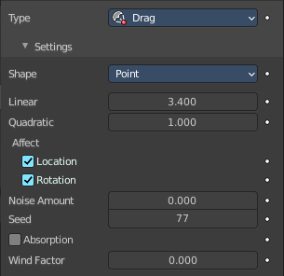
Create a force that dampens motion. The particles motion is slowing down.

Settings Subpanel

Shape
The direction that is used to calculate the effector force.

Linear
Drag component proportional to velocity.

Quadratic
Drag component proportional to square velocity.

Affect

Location
Affect the location of the particles.

Rotation
Affect the rotation of the particles.

Noise Amount
Amount of noise for the force effect.

Seed
The random seed for the noise amount.

Absorption
Force gets absorbed by collision objects.

Wind Factor
How much the force is reduced when acting parallel to a surface. Like a cloth.

Falloff Subpanel

Shape

Sphere
Falloff is uniform in all directions, as in a sphere.

Tube
Fall off results in a tube shaped force field. The Field’s Radial falloff can be adjusted, as well as the Minimum and Maximum distances of the field.

Cone
Fall off results in a cone shaped force field. Additional options are the same as those of Tube options.

Z Direction
Fall-off can be set to apply only in the direction of the positive Z Axis, negative Z Axis, or both.

Power (Power)
How the power of the force field changes with the distance from the force field. If r is the distance from the center of the object, the force changes with 1/rPower. A Fall-off of 2 changes the force field with 1/r2, which is the falloff of gravitational pull.

Min Distance
The distance from the object center, up to where the force field is effective with full strength. If you have a Fall-off of 0 this parameter does nothing, because the field is effective with full strength up to Max Dist (or the infinity). Shown by an additional circle around the object.

Max Distance
Makes the force field only take effect within a specified maximum radius (shown by an additional circle around the object).

Type Fluid Flow

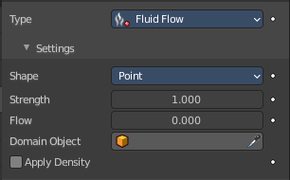
Create a force field based on fluid simulation velocities.

Settings Subpanel

Shape
The direction that is used to calculate the effector force.

Strength
The strength of the force.

Flow
Convert effector force into air force velocity.

Domain Object
Select Domain object of the smoke simulation.

Apply Density
Adjust force strength based on smoke density.

Falloff Subpanel

Shape

Sphere
Falloff is uniform in all directions, as in a sphere.

Tube
Fall off results in a tube shaped force field. The Field’s Radial falloff can be adjusted, as well as the Minimum and Maximum distances of the field.

Cone
Fall off results in a cone shaped force field. Additional options are the same as those of Tube options.

Z Direction
Fall-off can be set to apply only in the direction of the positive Z Axis, negative Z Axis, or both.

Power (Power)
How the power of the force field changes with the distance from the force field. If r is the distance from the center of the object, the force changes with 1/rPower. A Fall-off of 2 changes the force field with 1/r2, which is the falloff of gravitational pull.

Min Distance
The distance from the object center, up to where the force field is effective with full strength. If you have a Fall-off of 0 this parameter does nothing, because the field is effective with full strength up to Max Dist (or the infinity). Shown by an additional circle around the object.

Max Distance
Makes the force field only take effect within a specified maximum radius (shown by an additional circle around the object).

